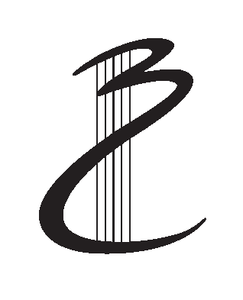
BRISBANE CHORALE
AUDITION FORM

To request an audition, please complete this form and email it to audition@brisbanechorale.org.au. We'll also answer any questions you might want to ask in your email - or you can first contact the Auditions Coordinator at the above email address or phone on 0421 634 518.
Title: | Title | Name: | Enter your full name

Street Address: | Enter your street address
Suburb: | Enter your suburb/town
State: | Enter your State
Postcode: | Enter your Postcode

Telephone
H: | Your Home phone | W: | Your Work phone | M: | Your Mobile

Email: | Enter your email address

Occupation: | Enter your occupation

I currently sing : | Sop 1 ☐ Sop 2 ☐ Alto 1: ☐ Alto 2: ☐
 | Ten 1 ☐ Ten 2 ☐ Bass 1 ☐ Bass 2 ☐

Age: DOB (optional): Date of Birth
Past Choirs

 | Name of choir/s | No. years in choir | Approx. size of choir
(1) | Enter the choir’s name | Enter the number of years | Enter the choir’s size
(2) | Enter the choir’s name | Enter the number of years | Enter the choir’s size

Present choir/s: | Enter the name of your present choir
Other singing experience:  (eg solos / arias, opera chorus, folk group, etc.) | Describe any other singing experience you have
Vocal training: | Describe what vocal training you have received
Instruments played & any music qualifications: | Describe what instruments you play & your music qualifications

Next of kin
Name: | Enter your next of kin’s name
Phone No.: | Enter your next of kin’s phone number

Languages (other than English) spoken: | List any languages you speak

How did you hear about the Brisbane Chorale? | Tell us how you heard about the Brisbane Chorale

